Stochastic simulation for an active Brownian particle

Author: Li,Qichao

Different from passive particles, active particles have the ability to propel themselves. They are capable of getting energy from the surrounding environment and converting it into directed motion, which as a result attracts the attention of my researchers to this area. Now, many scientists have been developing artificial self- propelling particles that can adapt to different crowded and complex environment, hoping to use them in autonomous agents for health care, security and so forth.

Here, to make problems easy to understand, we consider the simpler and more fundamental case of a single active Brownian particle in homogeneous environment without obstacles or other particles.

A. Create the model

Consider a spherical particle that self-propels with a constant speed ν along a given internal orientation direction in 2D. Here we consider there to be the thermal noise that only affects its rotation but not its translation. The direction of motion is subject to rotational diffusion, which leads to a coupling between rotation and translation. So, the equations determining the dynamics are

$$\left\{\begin{aligned}\frac{dx}{dt}=ν\cos\left(ψ\right) (1) \\ \frac{dy}{dt}=ν\sin\left(ψ\right) (2) \\ \frac{dψ}{dt}=\sqrt{2D_{R}}ξ (3)\end{aligned}\right.$$

Here the particle position is at r(t)=(x(t),y(t)) and the direction of motion is n(t) = cos(ψ(t))i + sin(ψ(t))j in two dimensions. The active velocity ν is a positive constant, $D_{R}$ is the rotational diffusion coefficient, $ξ$ is a Gaussian white noise satisfying <>=0 and <(t2)(t1)>=δ(t2-t1)

B. Autocorrelation of the direction of motion

To clearly see when and how the noise influence the direction of motion, here we use autocorrelation function to find the similarity between observations as a function of the time lag between them. The autocorrelation of the direction of motion is given by

$$〈n\left(s+t\right)∙n\left(s\right)〉=\underset{T→∞}{lim\frac{1}{T}}{\int_{0}^{T}{n\left(s+t\right)∙n\left(s\right)ds=\exp\left(-\frac{\left|t\right|}{τ_{R}}\right)}} (4)$$

where $τ_{R}$ is the orientational persistence time.

We do the simulation for $D_{R}$ =0.1, 0.4, 0.8 separately by computer to see the relationship between the autocorrelation and time t and how $D_{R}$ influence them. The following Fig.1 is just what we get from the simulation. All of the three plots show two different trends on both sides of a certain time, before which they follow the exponential law while the autocorrelation just fluctuate around 0 after that.

We also notice that, the turning point gradually move to left side as $D_{R}$ increases. This implies that, on average, an active Brownian particle will move along the direction of its initial orientation for a finite persistence period before its direction is randomized, and this period has an inverse correlation with $D_{R}$.

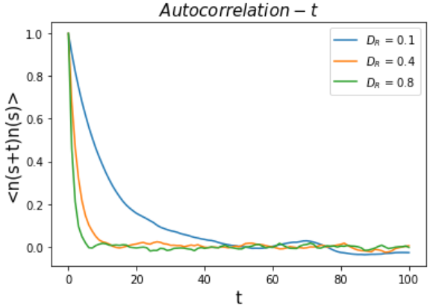

Fig.1.The autocorrelation of the direction of motion with time increasing in different $D_{R}$

Further, we carry out a lot more simulation for a set of selected values of $D_{R}$ while numerically computing and fitting the autocorrelation to an exponential function of t (for the first stage) to determine $τ_{R}$. After gaining many pairs of ($D_{R}$, $τ_{R}$), we plot a line (Fig.2) to find the dependence of $τ_{R}$ on $D_{R}$. Obviously, the figure shows that the orientational persistence time depends on the rotational diffusion coefficient through the relation $τ_{R}=1/D_{R}$.

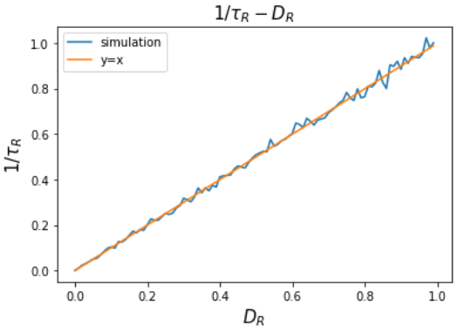

Figure.2. The dependence of $τ_{R}$ on $D_{R}$

C. Effective diffusion coefficient in two dimensions

An important quantity for characterizing the motion of microscopic systems is the mean square displacement (MSD). The MSD of a particle as a function of the time lapse t is

$$MSD \left(t\right)=〈{\left[r\left(t\right)-r\left(0\right)\right]}^{2}〉=〈{\left[x\left(t\right)-x\left(0\right)\right] }^{2}+{ \left[y\left(t\right)-y\left(0\right)\right]}^{2} 〉 \left(5\right)$$

The theoretical MSD(t) is given by

$$MSD\left(t\right)=2ν^{2}τ_{R}\left[t+τ_{R}(e^{-\frac{t}{τ_{R}}}-1)\right] (6)$$

By carrying out the simulation for the stochastic equations (1), (2) and (3), I simulate the trajectory of the particles with a set of selected values of ν and $τ_{R}=1/D_{R}$ and calculate their MSD(t) using E.q.(5). From the MSD, we can gain a lot of insights about the dynamics of a system.

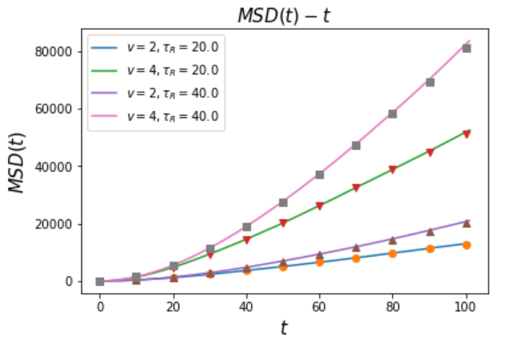

Figure.3. Numerically calculated (lines) and theoretical (symbols) MSD for an active Brownian particle with $ν$ = 2,4 and $τ_{R}$ = 20,40

Figure.3 shows both the calculated values and theoretical values of MSD. Since the calculated lines and theoretical symbols fit each other very well, we can prove that the theoretical result we give is correct. Here, we notice that when $t≫τ_{R}$, $MSD\left(t\right)≅2ν^{2}τ_{R}t$ (the linear relationship clearly to be seen in Figure.4), which means that the rotational diffusion leads to a randomization of the direction of propulsion and the particle undergoes a random walk whose step length is the product of the propelling velocity $ν$ and the rotational diffusion time $τ_{R}$. The effective diffusion coefficient $D_{eff}$ finally increases to $ν^{2}τ_{R}$/2.

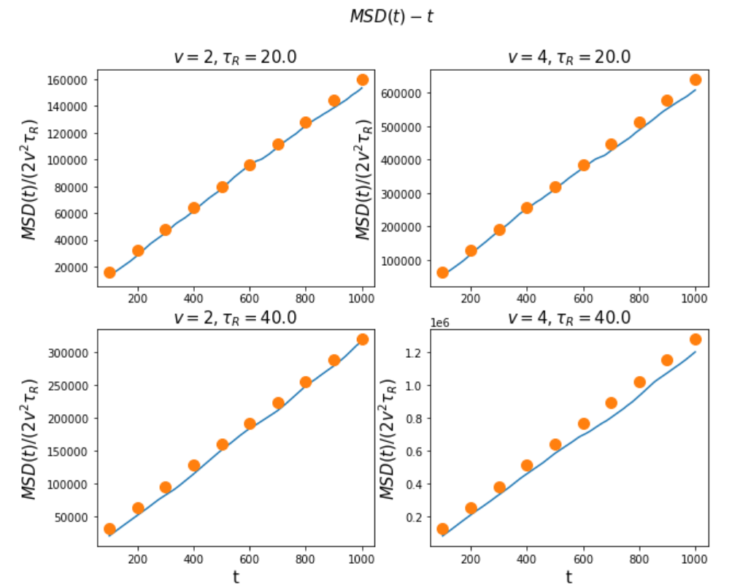

Figure.4. Relationship between MSD and $2ν^{2}τ_{R}t$ as $t≫τ_{R}$

Reference

[1] Bechinger, C., Di Leonardo, R., Löwen, H., Reichhardt, C., Volpe, G., & Volpe, G. (2016). Active particles in complex and crowded environments. Reviews of Modern Physics, 88(4), 045006.

[2] Romanczuk, P., Bär, M., Ebeling, W., Lindner, B., & Schimansky-Geier, L. (2012). Active Brownian particles. The European Physical Journal Special Topics, 202(1), 1-162.

[3] Selmeczi, D., Li, L., Pedersen, L. et al. Cell motility as random motion: A review. Eur. Phys. J. Spec. Top. 157, 1–15 (2008).

[4] Toschi, F., & Sega, M. (Eds.) (2019). Flowing matter. (Soft and Biological Matter). Springer.